XLeRobt JoyCon Control

+: right elbow flex down 💪
-: left elbow flex down 💪
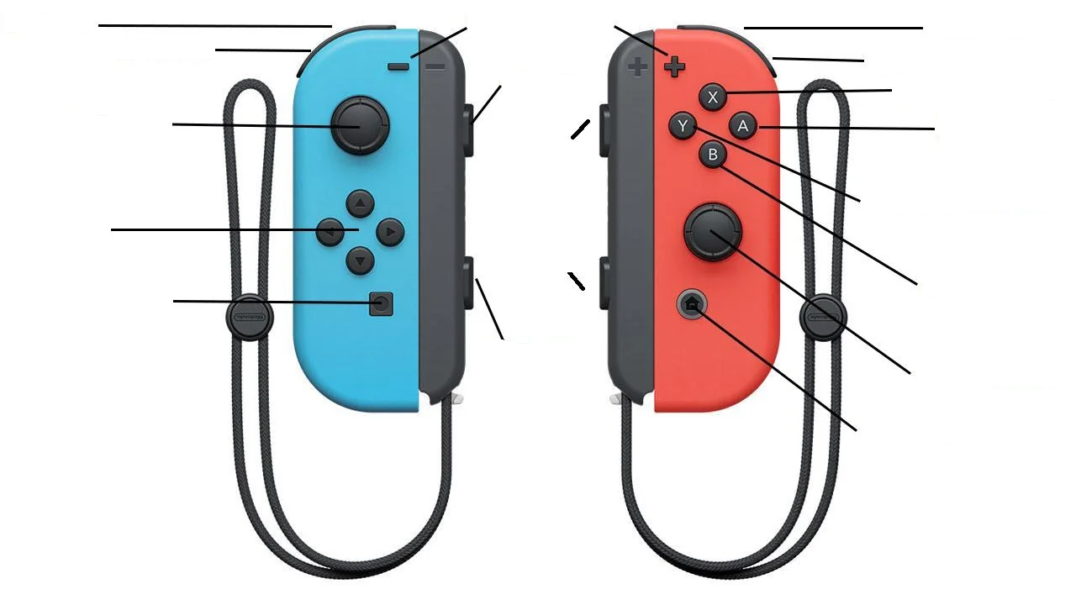
R: right elbow flex up 💪 down
L: left elbow flex up 💪
Capture: (+Home) quit 🔚
X: right shoulder lift up 🤷
ZR: (hold) right gripper open/close 🫳

ZL: (hold) left gripper open/close 🫳
Home: Sleep/Wake 💤
Left Stick: base Control 🛞
Up: move forward
Down: move backward
Left: turn left
Right: turn right
SL:
SR: base speed up
SL: base speed down
Right Stick: head control 🧑
Up: head lift (motor2) up
Down: head lift(motor2) down
Left: head pan(motor1) left
Right: head pan(motor2) right
B: right shoulder lift down
Y: right shoulder pan left
A: right shoulder pan right
D pad: left shoulder 🤷
Up: shoulder lift up
Down: shoulder lift down
Left: shoulder pan left
Right: shoulder pan right

SR:

